**KA JINGRAKHE DA KA KHASI DEPARTMENT ST.EDMUND’S COLLEGE ÏA KA SNGI KYRPANG KA KTIEN I MEI SHI TYLLUP KA PYRTHEI**

Ka Khasi Department, St. Edmund’s Kolej kum shi bynta ban pynkynmaw ïa ka jingdap 25 snem ka jingrakhe ïa ***ka sngi kyrpang jong ka Ktien I Mei ha shi tyllup ka pyrthei*** lane ka **International Mother Language Day** ba la buh da ka UNESCO man ka 21 tarik u Rymphang, ka la ïoh ban pynlong ïa ka prokram hapoh ka Kolej mynta ka sngi ka 20 tarik u Rymphang, 2025. La hap ban pynlong noh shi sngi shwa ka sngi ba buh namar ka ïatyngkhuh bad ka elekson MDC. Ha kane ka sngi la ïashim bynta da ki Samla Pule na ka Khasi department bad ki Samla Pule kiba shim ïa ka AEC- Khasi. Ka program ka la long shisha kaba ai jingmyntoi shibun ïa ki Samla Pule ba kin ñiewkor bad ban burom ïa la ka ktien lajong bad khlem da klet ruh ban ïaleh ban nang ïa kiwei ki jait ktien ruh kiba don ha kane ka pyrthei. Ha kane ka prokram ka phang ka long ***“Im ka Ktien, im ka jaitbynriew”***. ki Samla Pule ki la ïoh jingmyntoi shibun ha kaba ïadei bad ka jingkordor jong ka ktien Khasi bad khamtam ïa ka jingdonkam jong ka ban ïoh rung noh ha ka Khyrnit kaba Phra jong ka Riti Synshar ka Ri India. U Riewshemphang ha kane ka prokram u dei u Dr Ronald P. Kharshiing, u Nonghikai Khasi Department, St. Edmund’s College bad uba long ruh u Genl. Secretary ka KAS, la ïoh ruh ka jingkren lyngkot na u Babu Bobby S. Basan (HOD) bad na i Dr (Mrs) B.W. Nongbri (DEAN) bad nalor kane la pynphuh pynphieng ruh ïa kane ka prokram da ka poster campaign ha kaba ki Samla Pule na ki jait ktien bapher bapher ki la ïoh ka lad ban thoh ha ka White Board ba la pynïeng ha phyllaw jong ka Kolej ban pynpaw ïa ka jingieit jong ki ïa la ka jong ka ktien.

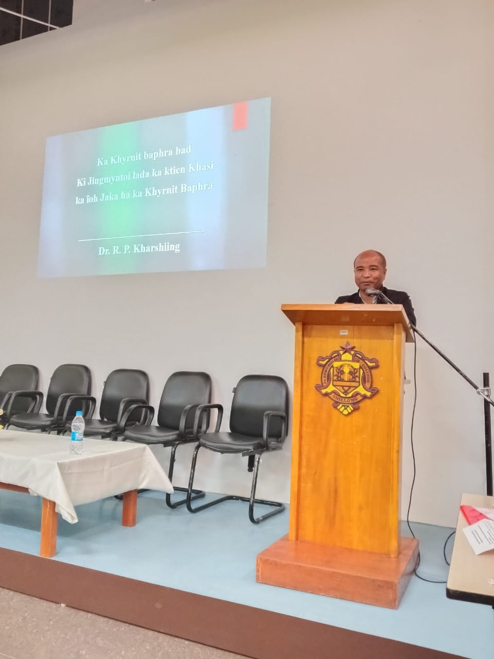

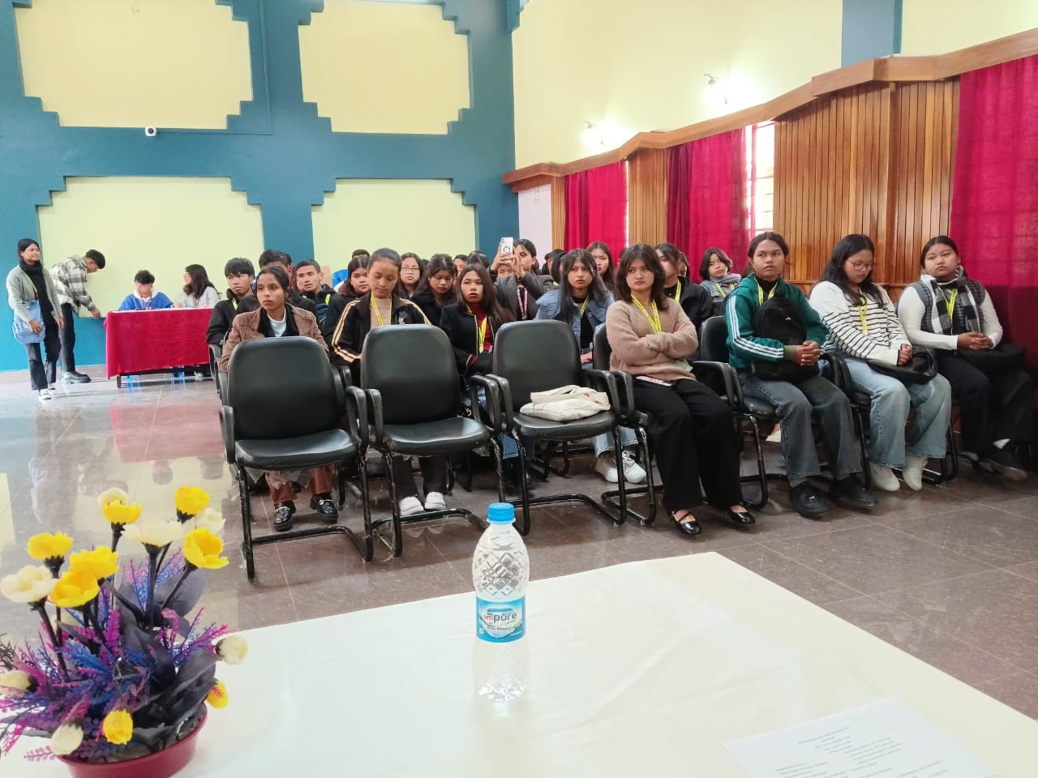

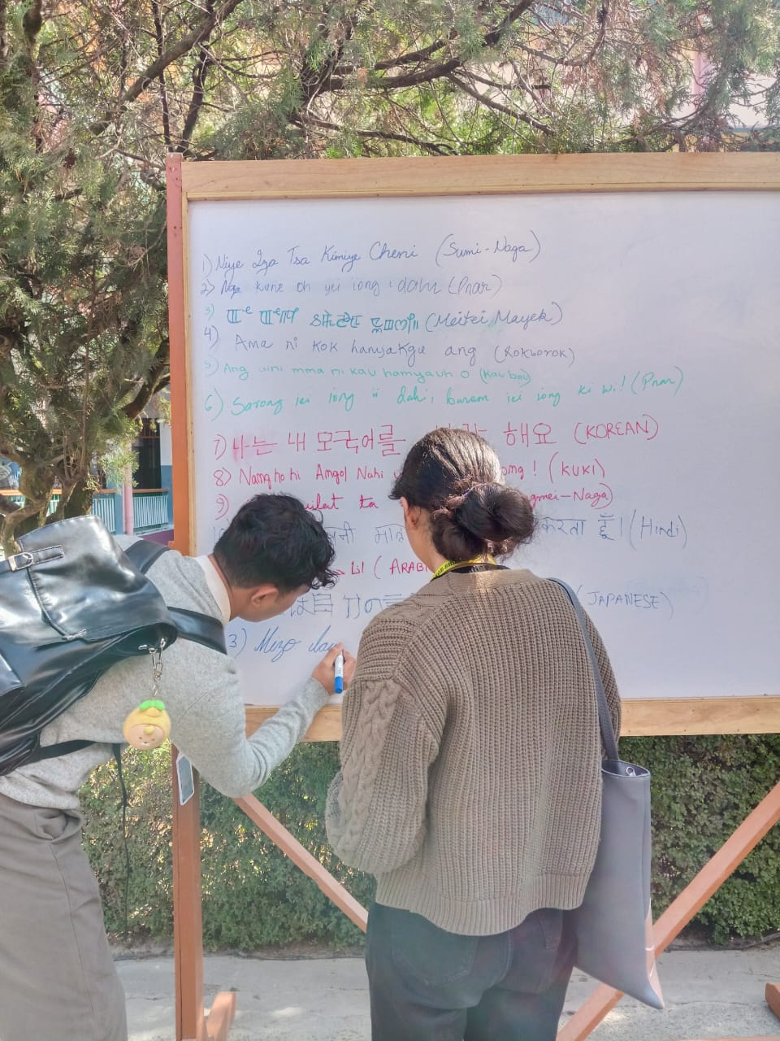

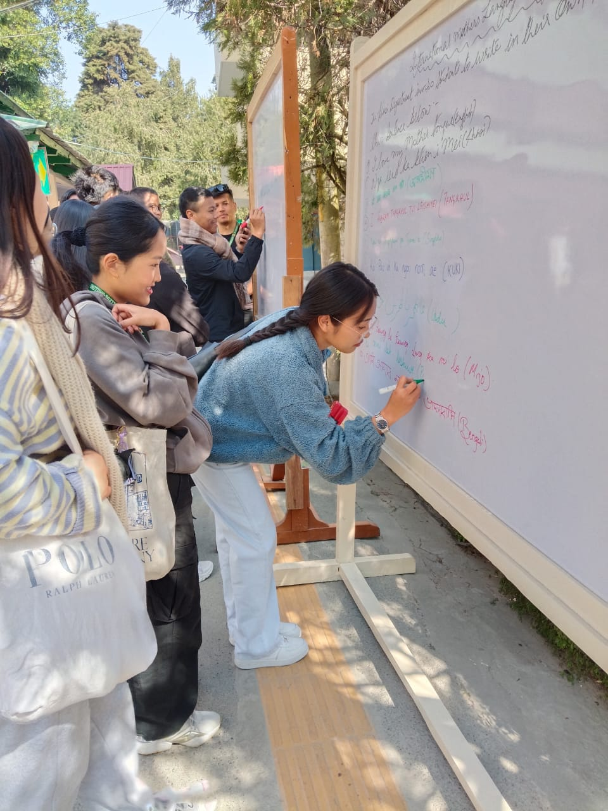

**OBSERVATION OF INTERNATIONAL MOTHER LANGUAGE DAY by KHASI DEPARTMENT, ST.EDMUND'S COLLEGE**

The Khasi Department, commemorating 25 years of the observation of International Mother Language Day as instituted by UNESCO on the 21st February, the College anticipated the observation today, the 20th of February 2025,in view of the MDC elections scheduled on the 21st of February. The students of the Khasi Department along with the AEC students--Khasi, participated in the programme. It was a remarkable and favourable programme, it serves as a reminder to the students to value their mother language while trying to learn other languages of the world. The theme of the programme is, "Where language is alive, a tribe thrives". The students were enlightened on the value of the Khasi Language and the paramount importance of the inclusion of the language in the Eight Schedule of the Constitition of India. One of the faculty member of the Khasi Department, St. Edmund's College. Dr Ronald P. Kharshiing, serves as the resource person, it may be noted that he is also the General Secretary of the Khasi Authors Society. To create more impact on the participants, Bobby S. Basan (HOD), as well as Dr(Mrs) B.W. Nongbri (the Dean),addressed the gathering. In addition to the programme, there was also a poster campaign where students of varied languages participated with enthusiasm to express their love of their mother tongue by displaying their scripts on a White Board posted in the college campus.